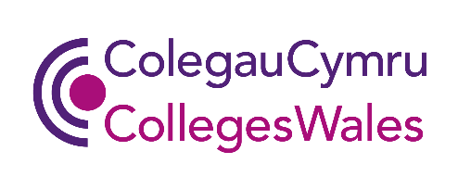

RARPA Peer Exchange Guidance
March 2023
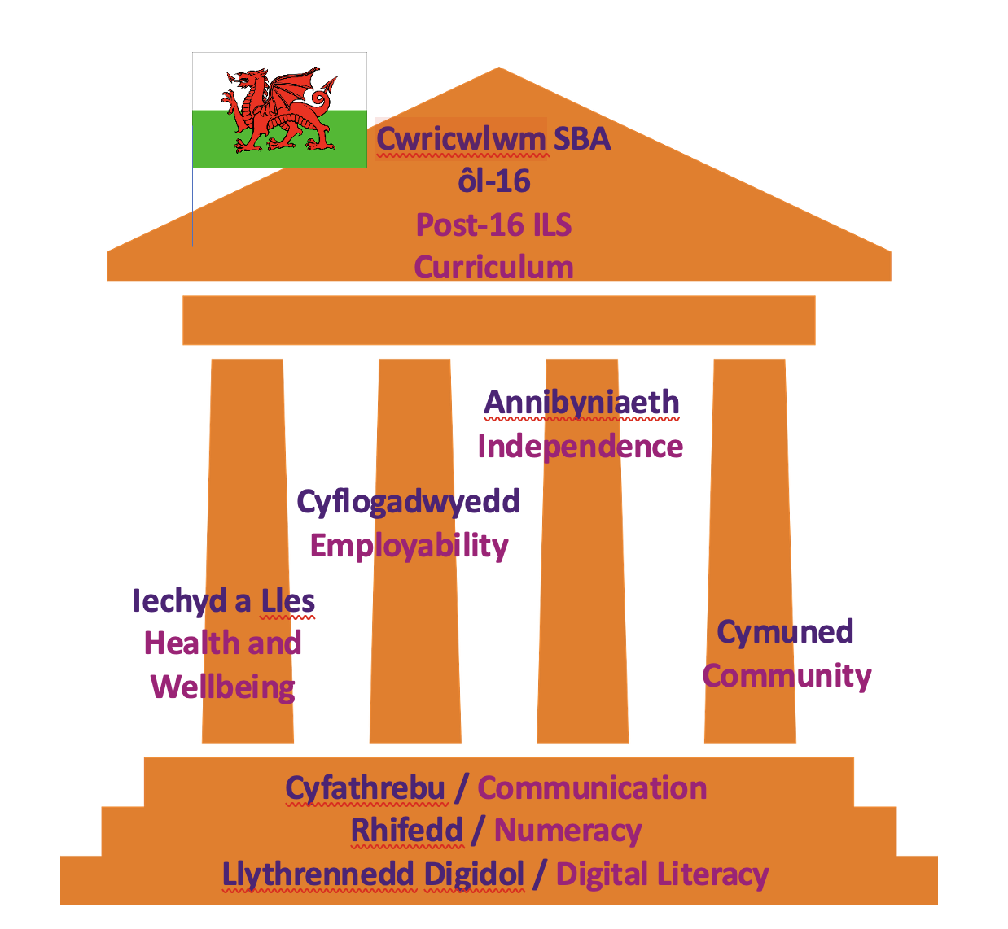

Contents
1. Introduction 2
1.1 2
1.2 2
1.3 2
2. The Post-16 ILS curriculum in Wales 2
2.1 2
2.2 1
2.3 1
3. What is RARPA? 1
3.1 1
4. What is peer exchange? 3
4.1 3
4.2 3
5. The Peer exchange process - how does it work? 5
5.1 Linking with another college 5
5.2 First meetings 6
5.3 Sharing processes and documents 6
5.4 Samples and evidence 6
5.5 Observations 6
5.6 Learner voice 6
5.7 Peer exchange meetings 7
5.8 Document completion 7
Appendix 1 - College Partnerships 2022/2023 9
Appendix 2 - Learner Journey and document checklist 9
Appendix 3 - Peer Review Forms 9

1. Introduction

1.1
Welcome to the Post 16 Wales Peer exchange guidance document. This document has been produced by ColegauCymru, working with a task and finish group from the ColegauCymru Independent Living Skills (ILS) Network. The work has been funded by the Welsh Government.

1.2
This guidance document suggests ways of conducting an effective peer exchange within and between Further Education colleges for ILS provision. The peer exchange process has been developed in order to ensure that high quality standards in the ILS curriculum are maintained across Wales. The purpose of the exchange is to check, standardise and improve RARPA (Recognising and recording progress and achievement) quality assurance processes and systems associated with non-accredited curriculum, for learners with learning difficulties/disabilities within the FE environment. The peer exchange process is vital as a minimum standard for external quality assurance, it should be carried out on a yearly basis and given the same priority as the external verification process used in accredited learning. This guidance will be useful for managers and practitioners working with post 16 learners with learning difficulties/disabilities, who are following Independent Living Skills programmes of study and using a non-accredited curriculum.

1.3
The guidance includes:
- Background information about the ILS curriculum
- Information about RARPA
- Quality assurance processes and the place of peer reviews within the quality cycle,
- Definitions of quality assurance terms in relation to non-accredited curriculum
- The essential components of a peer exchange
- Benefits of conducting a peer exchange
- The peer exchange process
- Templates that can be used or adapted by colleges to use when conducting peer exchanges

2. The Post-16 ILS curriculum in Wales

2.1
The revision of the ILS curriculum including the move to a non-accredited curriculum for learners with learning difficulties/disabilities, took place in response to the recommendations set out in the recent Estyn Thematic Report. The new curriculum is designed to provide a practical approach to skills development in order to prepare learners for adult life.

2.2
The curriculum is based around a core of four learning pillars:
- health and wellbeing,
- community inclusion,
- independent living skills and
- employability.
Communication skills, numeracy skills, and digital literacy skills are embedded within each of the four pillars.
The curriculum is person-centred and destination led, with a shift from a qualifications-based delivery model to one that focuses on individual learner achievement.
There are four full-time learning programmes;
Pathway 1 - for learners with profound and multiple learning difficulties and/or disabilities, in preparation for adult life in the community,
Pathway 2 – for learners with severe learning difficulties and/or disabilities; in preparation for adult life in the community and employment/supported employment opportunities,
Pathway 3 – for learners with moderate learning difficulties and/or social or behavioural difficulties and/or disabilities, in preparation for progress to mainstream courses or to employment opportunities,
Pathway 4 – for learners with learning difficulties/and or disabilities whose goal is employment (includes supported internships)

2.3
Effective and measurable systems of tracking progress and achievement are essential, a RARPA quality assurance process for Wales has been developed and a toolkit produced by the group that includes a self-assessment document and guidance documents. Use of this RARPA self-assessment is now a mandatory requirement for WG funding.

3. What is RARPA?

3.1
RARPA (Recognising and recording progress and achievement) is a five-stage process that providers can use to measure how well learners are making progress towards their identified chosen destinations. It is based on person-centred values, keeping the learner at the centre of the process so they can achieve their aspirations and long-term outcomes.

Key Performance indicators There is a need for measurable data for ILS programmes, but the key performance indicators for learners enrolled on non-accredited programmes will be different to the rest of the college. The key performance indicators will include reporting data on
- Achievement - Learner progress on targets set. This may include accreditation where that is relevant to the learners next step or destination.
- Value added - Taking into account learners starting points and the individual progress that they have made
- Destinations - These may include progress to:
  - an active life in the local community,
  - meaningful employment (this could include supported employment)
  - supported internship opportunities,
  - further learning (only if educationally relevant, not a revolving door process just to provide respite), progress to meaningful employment, and progress to adult life in the community

- Success measures For all learners on ILS programmes, measures of success are judged on an individual basis, with different learners on the same programme having very different outcomes. Most of ILS learning is non-accredited and, rather than measuring success by qualifications and certificates gained, success is measured by the achievement of meaningful, relevant educational targets that help learners make progress into work opportunities and into adult life.
- Progression is not limited to the completion of the academic year. While most learners will complete their courses there are some who may achieve their targets and gain employment before the end of the academic year. Leaving early, in these circumstances, will be recognised as a good progression.

Quality assurance and RARPA

Quality assurance systems should be in place to measure and self-assess the quality of programmes throughout the year and at each of the stages of the RARPA process. This includes both internal and external verification of programmes.

- Self-assessment, Internal Quality Assurance and Internal reviews - These are the review processes carried out by the organisation. The RARPA internal review process is usually conducted by practitioners and managers for the programme area. It should be a process of self-assessment that takes place across the year, with staff reflecting on each of the five stages of RARPA after they take place. The second part of the process reviews the organisation systems for quality assurance (Q 6,7, and 8) and is usually conducted by managers who have responsibility for the programme area. The completed review identifies best practice and actions required to improve performance. The internal review should dovetail into the organisation’s usual quality cycle. A RARPA self-assessment framework document template for Wales and a guidance document to support the process can be found within the Post-16 Independent Living Skills Network on Hwb. The self-assessment documents can also be found on the RARPA Padlet link under the column ‘Current published documents in Wales.’ The Padlet can be found here.

- External Quality Assurance and Reviews - Some providers may find it useful to commission an external review of RARPA learning programmes to ensure that the quality system is robust and equal to the rigour that accredited programmes undergo. Such a review should involve an external professional with knowledge of the ILS curriculum and expertise in delivering and quality assuring RARPA programmes.

- Peer Exchange - The peer exchange process is a vital part of the quality assurance process. It has been developed and agreed by ILS managers and practitioners working with the ColegauCymru Network and has been approved by the ColegauCymru Curriculum and Quality Network. It offers the opportunity for sharing effective practice, reviewing each other’s programme as well as providing external verification and standardisation across Wales.

4. What is peer exchange?
Peer Exchange
‘a small group of providers work in partnership to review each other’s RARPA provision.’ ETF, RARPA Guidance, page 67

4.1
Peer exchange can be
- Internal - between staff and managers on different campuses
- External - Between providers of the same type or sector, or between different sectors e.g., FE institutions working with Special Schools or Specialist Colleges

4.2
The purpose of peer exchange is to identify and share effective practice between providers. It can involve a range of staff with different roles including managers, practitioners, and support staff. As well as providing an opportunity for standardising and ensuring rigour in RARPA practice it also provides valuable CPD opportunities for those taking part in the process.

Peer exchange needs to be:

- Realistic; considering the current situation
- Rigorous
- Honest
- Conducted with professional respect
- A positive process– encouraging continuous improvement for all who take part
- Recognised within the college quality system

The peer exchange system that we are developing for post 16 provision in Wales should be used to inform areas for quality improvement plans both regionally and nationally.

Benefits of conducting a RARPA peer exchange

For individual members of staff involved
An opportunity to:
- Reflect on own practice, challenge practice habits and confirm what works well
- Share innovative practice and gain ideas for own setting
- Network with others using RARPA to develop and test ideas for improving practice
- Standardise and ensure rigour in RARPA for learners

For the college
- Gives additional external quality feedback that can be used to inform own quality system
- Provides opportunities for staff involved in the process to improve own practice
- Brings new and innovative ideas, tested elsewhere, that can be developed to improve teaching practice and learning environments
- Develops positive and useful networks with partner colleges

For the sector
- Provides an additional standardisation of RARPA systems
- Encourages an atmosphere of open dialogue and networking between colleges
- Develops a culture of sharing effective practice and continuous improvement across the sector

5. The Peer exchange process - how does it work?

5.1 Linking with another college

Partnerships for the Peer exchange pilot have been agreed with the ColegauCymru ILS network, the Quality and Curriculum network and the Principals Forum. The list of these can be found in Appendix 1.

- ILS Leads will link at the start of the academic year but with full knowledge support/agreement of the senior management team and set up a calendar of peer exchange activity for the year.
- Exchange activities will cover the academic year and include a mix of phone conversations; exchanges of documentation via electronic means (e.g. targets, initial assessments); visits and an agreed date for completing peer exchange documentation.

5.2 First meetings

Can be held online. This meeting is an opportunity to understand the provision and to scope out areas of mutual interest. These discussions should take place in the Autumn term.

5.3 Sharing processes and documents

This can be conducted electronically. All materials should be anonymised in line with the colleges GDPR policies and procedures.

5.4 Samples and evidence

The sample needs to be manageable. It does not need to include provision from the whole college and can be limited to one campus. It should include a range of at least two pathways with a minimum of evidence from two learners; one from each pathway. This is not an exercise in publicity and the sample should include a range of abilities. It could include work that you have concerns about, where constructive feedback would be helpful.

Documents shared should include:

- Initial assessment and results for the learners sampled
- Targets - showing the link to initial assessment and destination information
- Evidence of progress against targets (Video, Seesaw or similar, photos, witness)
- exchange documentation

See appendix 2 for a list of other documents that could be used as part of the exchange process

Key questions when sampling evidence
How does this evidence progress towards targets?
Is learning relevant for progress for the learner’s next step?

5.5 Observations

Peer exchange does not include formal observation of practice. Informal observation for the purpose of sharing innovative teaching and learning practice can be carried out if mutually agreed.

5.6 Learner voice

Informal chats with learners are encouraged as well as sharing of any learner voice material.

5.7 Peer exchange meetings
A meeting could take place part way through the year, so that useful feedback can be acted on across the year. A final meeting should also be conducted to conclude the process.

5.8 Document completion

There are two documents linked to the peer exchange process.

Form 1 is a sampling form for use when sampling learner evidence. The form is to help those taking part in the peer review process identify the effectiveness of RARPA processes for the learner and make comments that can be used for making improvements. The form identifies strengths to be shared as good practice and suggestions for areas to develop. It also identifies practice that the peer reviewer can learn from and share with their own organisation. This form should be used by all those taking part in the peer exchange process.

Form 2 is the External check by peer review report form. One copy only of this should be completed after the peer exchange process by the lead peer reviewer.

Complete the fields in the report form relevant to the agreement that you have made with your partner college. If you had agreed that some of the RARPA standards were out of scope for the external check, then you should note ‘not reviewed’ in these fields.

For each of the 8 RARPA standards included in the review:
- give a clear indication of your findings
- highlight areas of good practice
- specify what actions for improvement the organisation needs to take if its performance is to meet the requirements
- confirm whether the organisation has carried out any previously agreed actions for improvement (from previous external checks or internal self-assessment activity)
- record any areas where there was insufficient evidence to form a decision or where the evidence reviewed did not support the provider’s self-assessment

Finally, make a note of any specific learning you have gained from the review which will be of value in your organisation.

Comments should be:
- realistic – considering the current situation and environment that the organisation is working in,
- Rigorous and honest
- Written with professional respect that encourages continuous improvement for all taking part

The findings should be fed back verbally at the end of the peer exchange process and agreed by both organisations before being finalised. There is space on the document for identifying valuable learning and effective practice that the peer reviewers can learn from and share within their own organisations.

Useful links and further information:
Natspec RARPA resources

Appendix 1 - College Partnerships 2022/2023

Grwp Llandrillo Menai – Jane Myatt and Eleri Davies |  | Coleg Cambria – Jo Fisher, Deborah Lister and Lyn Morris
NPTC Group of Colleges – Julie Mercer and Sara Powell |  | Bridgend College – Greg Cavill and Kerry Hunter
Coleg Gwent - Gary Handley |  | Pembrokeshire College – Emma Jones and Sian Thompson
Coleg Sir Gâr (including Ceredigion) Sian Russell |  | Gower College Swansea – Simon Pardoe and Michelle Williams
Cardiff and Vale College – Ben Edwards and James Donaldson | Coleg y Cymoedd – Lauren Alexander |  | The College Merthyr Tydfil – Amanda Wilde and Kate Payne
Peer exchange timetable 2023 - 2027

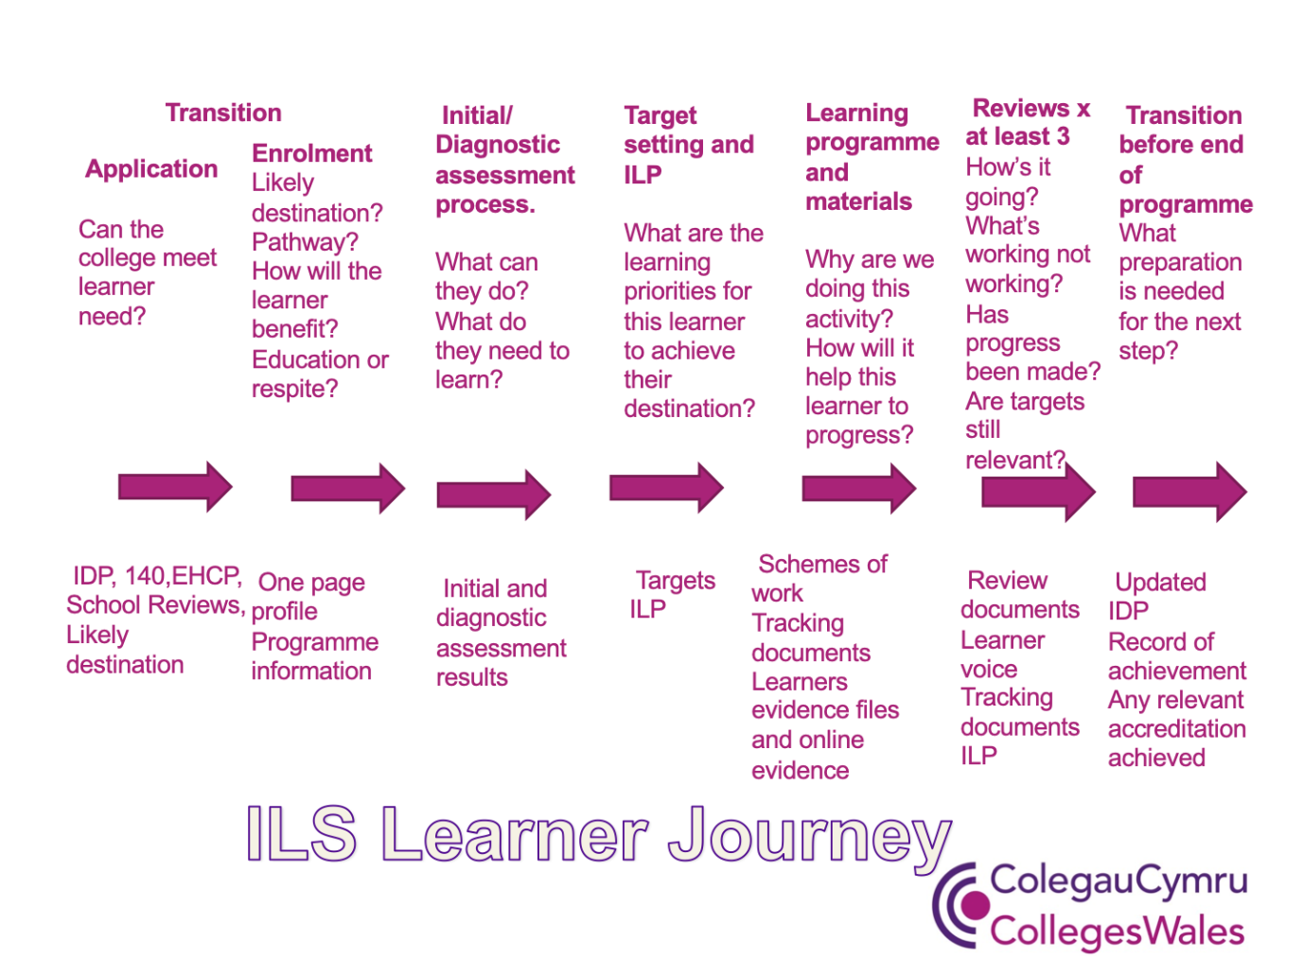
Appendix 2 - Learner Journey and document checklist

Appendix 3 - Peer Review Forms
ILS Peer Exchange Form 1 - Sampling of Learner Experience
ILS Peer Exchange Form 2 - External Check by Peer Review

